Name___________________________

Section__________________________

Department of Statistics

The Wharton School
University of Pennsylvania

Statistics 603 August 2010

QUIZ 1

Instructions

1. Place your name and section at the top of this page.
2. Keep this side up until you are given the instruction to begin.
3. This is a closed-book exam. You may use a calculator.
4. Circle the best answer to each question.
5. You will have exactly 8 minutes to complete the quiz.

A company tracks weekly sales at its 60 retail outlets which are located in 5 cities. The data are recorded in units of thousands of dollars.

- The following plot shows a summary of the data from a recent week for each of the 60 outlets.
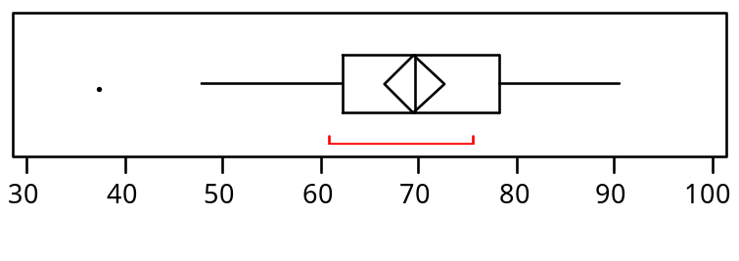
Based on this summary, the company can conclude that during this week, the 30 highest selling outlets had sales of
(a) around $70,000
(b) at least $70,000
(c) around $80,000
(d) more than $80,000

(2) In order to tell whether variation in sales depends upon location, the analyst should look at which of the following plots?
(a) Comparison boxplots of sales by location
(b) Histogram of sales
(c) Normal quantile plot of sales
(d) Time series (sequence) plot of sales

(3) Which of the following plots will best tell the analyst if the sales data are normally distributed?
(a) Comparison boxplots of sales by location
(b) Histogram of sales
(c) Normal quantile plot of sales
(d) Time series (sequence) plot of sales

(4) Suppose that a histogram of weekly sales at a particular outlet follows a normal curve with an average of $100,000 and a standard deviation of $15,000. About what proportion of their weekly sales are more than $130,000?
(a) 0.500
(b) 0.150
(c) 0.050
(d) 0.025

(5) In Assignment 1, you studied quarterly sales (in $1000) of Marshall Field & Co from the 1st quarter of 1960 through the 4th quarter of 1975, and then used this data to forecast sales for the 1st quarter of 1976. Which of the following were needed to compute this forecast?
- the quarterly sales for the 2nd quarter of 1975
- the mean of the quarterly relative sales changes from the 4th quarter to the 1st quarter
- both (a) and (b)
- neither (a) nor (b)

